

**RETURN TO NATURE GROUP**

**BALALLY PARISH**

AIM: To return 30% of Church grounds to nature by 2030

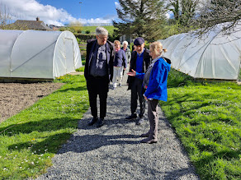

*Visit to An Tairseach Ecology Centre, Wicklow, April 2024*

Chair: Paul Murphy

Please contact Paul at: [pmurphyj@gmail.com](mailto:pmurphyj@gmail.com) if you would like to join

this working group OR offer ideas/suggestions for the project