A Word from Fr Jim

Happy Balally Feast Day– Ascension Sunday.
How blessed we all are to live in such a beautiful parish. Let us always welcome newcomers together, let us put our vision and mission into practise by making disciples of Jesus and Building Hope through Meditation & Service.
We had a beautiful visit from Sr Franca and Sr Margaret, Holy Rosary Sisters last Sunday. What a wonderful witness they gave and what generosity you showed them as usual,
typical of the generosity of the people of Balally.
We have a hidden gem in our parish, the carving of Our Lady of Balally at the
north – east side of the Church. It is a gift from the Carmelite Community of
Gort Muire and was created by Domhnall Ó Murchadha.
It is a beautiful piece of work and contains a lot of good theology and spirituality.
It overcomes the “Piety” of some images and places Mary as Mother of the Church
and Mother of our parish. Some notable features.
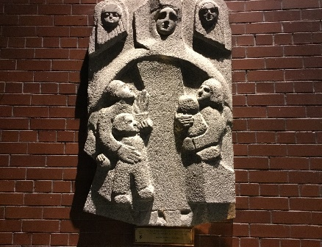

At the bottom of the piece we see four people, a man, a woman and two children. This represents the parish families, single people, the young and the old.
Mary’s cloak around us all, encompassing and including us as we pray.
It is a “protective cloak” This is an Italian idea, the Madonna della Misericordia our caring Madonna, the Lady of Mercy. Mary has a crown which is “Local” the crown of Our Lady of Knock. As we as a parish pray, it is with Mary, not to Mary, it reminds us of Mary praying with and for the disciples at Pentecost and the two angels beside her remind us that she prays with them to God. Mary never points to herself but to Jesus. Interestingly, Domhnall says that it is not a photograph, but an Icon style depiction of Mary. As is Knock she is silent but is the model of continuous prayer like John Main asking us to pray our Mantra, Maranatha, continuously. I will leave the last word to Domhnall. “I pray that Our Lady of Balally will help the families of Balally to see Mary as first Christian, protecting us and leading us to Christ Make sure this May to look and pray with Mary for all our needs. Our Lady of Balally Pray for us. Maranatha
With my love and blessing. Fr Jim

