

**A Word from Fr Jim**

The prolonged standing ovation for Mary Robinson at the end of her talk at the School of Contemplative Leadership said it all.

Now as we approach 2025 we need to move from talking to actively calling and preparing new leaders in our parish. The focus now switches to Advent and Christmas .

This weekend we will have James Murphy to speak about Dorothy Day

at 10am Mass and distribute the Advent book. She is a remarkable woman

of Prayer and Service a model and future saint.

We also commemorate the dead for Naomh Olaf’s GAA .

How blessed we are to have this wonderful club in our parish.

4

**Launch of new book**

**“The People’s celebration of the Eucharist “**

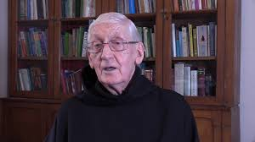

We are delighted that Fr Fintan from Glenstal Abbey (ex C.C Balally) has written a new book.

It will be launched by Fr Dermot here in Balally **on Wednesday 20th November @ 7.00pm**

All Fr Fintan’s balally friends are very welcome .

**With My Love & Blessing**

**Fr Jim**